Application Pages Documentation

1. Login Page
Page Name: Login Page
Description: The Login Page allows existing users to securely access their accounts. It provides a simple and user-friendly authentication interface to verify the user’s identity before granting access to the system.
Main Components: - Email input field - Password input field - “Forgot Password” link for account recovery - Login button - Option to sign in using Google - Link to navigate to the Sign Up page
Purpose: To authenticate registered users and allow them to access the application features.
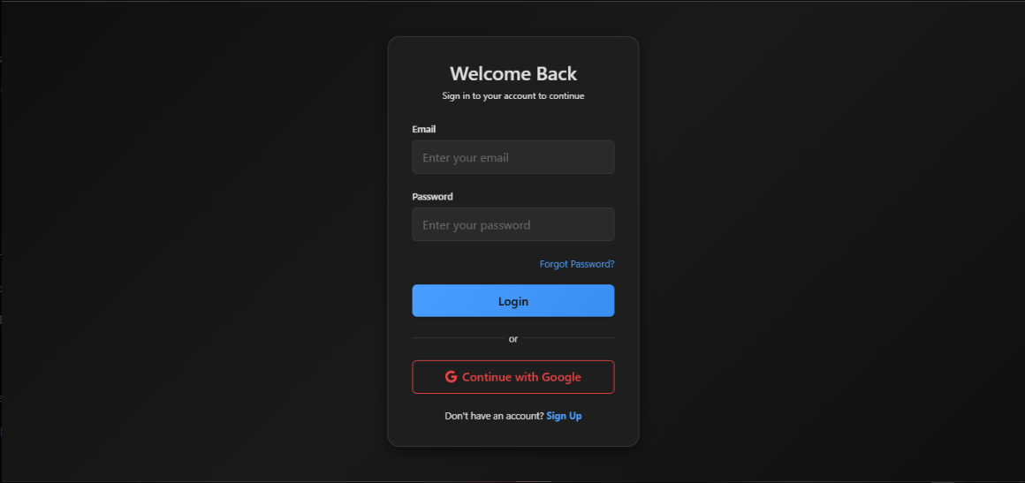

2. Sign Up Page
Page Name: Sign Up / Create Account Page
Description: The Sign Up Page enables new users to create an account in the application. It collects basic user information and allows quick registration using either email/password or Google authentication.
Main Components: - Full name input field - Email input field - Password input field - Sign Up button - Option to register using Google - Link to navigate back to the Login page
Purpose: To register new users and store their account information in the system.
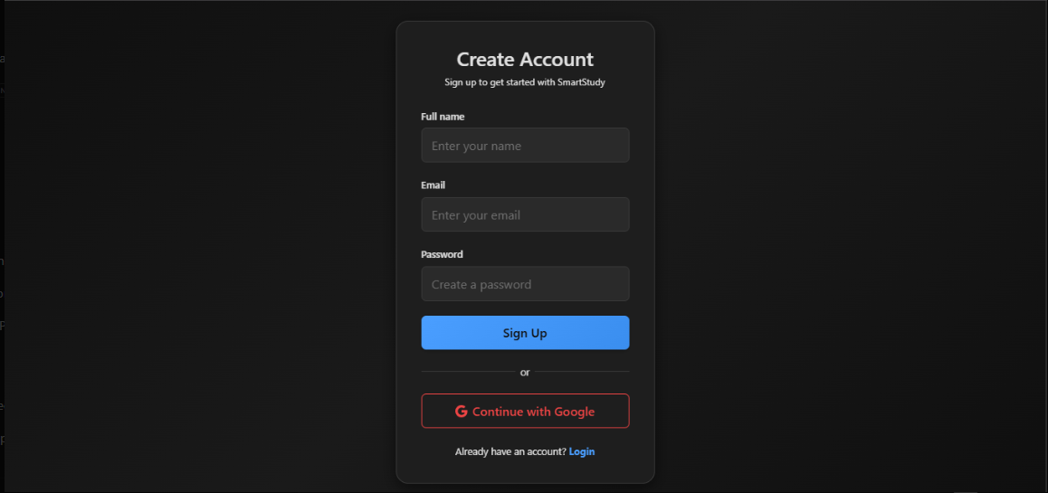

3. Chat Dashboard Page
Page Name: Chat Dashboard / Chat Interface
Description: The Chat Dashboard is the main interface of the application after a successful login. It allows users to start new conversations, view previous chats, and interact with the AI or chat system in real time.
Main Components: - User profile section in the sidebar - List of previous conversations - “New Chat” button - Chat messages display area - Message input field - Send button
Purpose: To provide users with an interactive chat experience and manage their conversations efficiently.

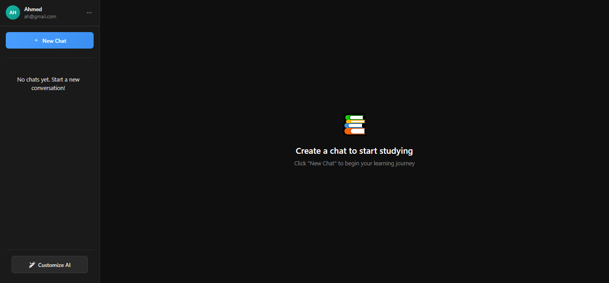
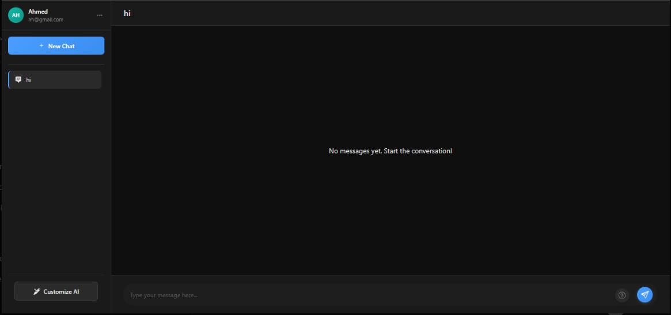
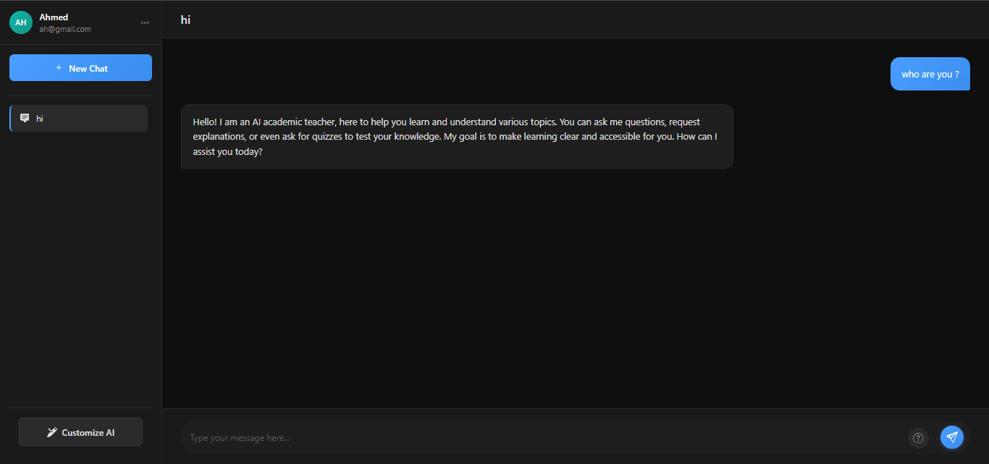
You can also Customize the AI in the way you want to answer.
